MACH4METAL

metalworking machinery
Transito 21
6909 DA BABBERICH Netherlands
Tel. +31 (0)316-247123
Fax: +31 (0)316-247956
info@mach4metal.com
www.mach4metal.com

Bank No : 66.52.13.883
IBAN : NL33 INGB 0665 2138 83
BIC : INGBNL2A

WEINBRENNER 4000 x 1250 ton
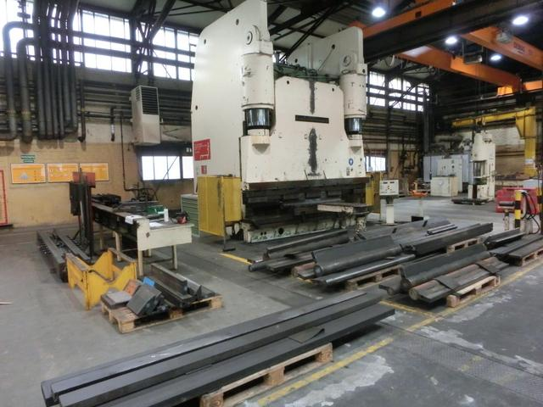
- Make : WEINBRENNER Germany
- Typ : AP 1250
- Mach.No : 516 A
- Yop : 1976

- Max. bending length : 4.000 mm
- Between column : 3.050 mm
- Max. Force : 1.250 Ton

- Die height : 1.000 mm
- Stroke : 350 mm
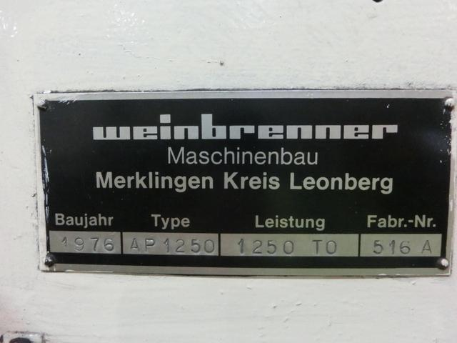
- Throat : 450 mm
- Min table – beam : 650 mm
- Table width : 4.200 mm
- Table height : 350 mm

- Approch speed : 45 mm/min.
- Working speed : 6 mm/min.
- Return speed : 50 mm/min.

- Dimensions
- Length : 4.200
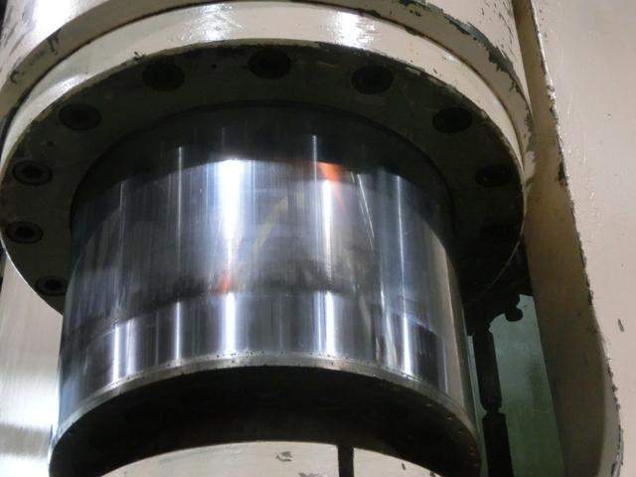
- Width : 3.500
- Height : 5.500
- Table height: 95.000
- Power : 2 x 30 kW

- Large tooling package
- Machine is build in floor
- Oil tank : L

Please Note: The above information has been obtained to the best of our ability and belief from, and from the manufacturers where possible. It is given in good faith, but its accuracy can not be guaranteed. Accordingly, it will not form a representation or constitute contractual terms. We advise you to check any vital details!

